File permissions in Linux

Project description

The research team at my organization needs to update the file permissions for certain files and directories, and in this project I used Bash commands to secure the fields based on authorization levels. I use common Bash commands such as ls, chmod, cd, etc. to modify all files and ensure the principle of least privilege by limiting each file’s access to only the users who need to access them.

Check file and directory details
First, I used ls -la find all files, including hidden files, and view their current permissions by the Linux User, Group, and Other permission types.
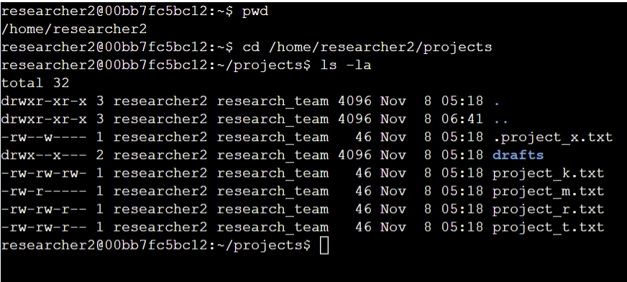

Describe the permissions string

The permission strings output by the ls -la command tell me if the file is a directory or a file and what permissions the User, Group, and Other permission types have. Each permission type has set permissions for read, write, and execute.

For example, the project_k.txt file has the permission string “-rw-rw-rw-“ meaning that it is a file (and not a directory) and each permission group has “rw-“ permissions, which allows each group to read, write, but not execute the file.

Many of the listed files and directories currently have incorrect permissions. For example, files like .project_x.txt still allow Group users to write to the file but this should not be allowed as it is an archived file.

Change file permissions

The organization does not allow the Other permission group to have write access to any files. As we can see from the permission strings, the file project_k.txt still has write access for the Other group.

I removed write access for the Other group on the file using the chmod bash command:

Then I can confirm that project_k.txt now only allows users in the Other group to read the file.

The file project_m.txt is a restricted file and should not be readable or writable by the group or other; only the user should have these permissions on this file. List the contents and permissions of the current directory and check if the group has read or write permissions.

Change permissions of the project_m.txt file so that the group doesn’t have read or write permissions.

Change file permissions on a hidden file
As mentioned earlier, the .project_x.txt file is an archived file that should not have write permissions for anyone. However, it still should be able to be read by the User and Group permission groups.
I first modified the access permissions to the file by removing any current write permissions and ensuring that the User and Group permission groups can read the file.
Then I verified that the correct groups have read access.

Change directory permissions

Finally, I modified the access permissions of any directories as they only belong to the User, no other permission groups should have permissions with the directories.
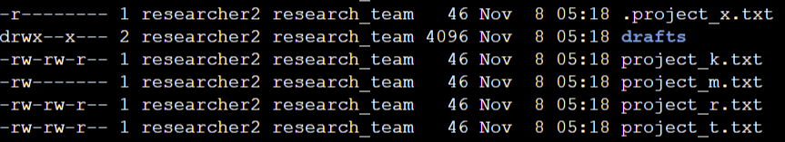

Using chmod, I updated the permissions of the draft directory to ensure that the current execute permissions for the Group permission group are removed.

Now the directory only allows the User to have any access permissions.

Summary
File and directory access permissions are very important to manage as a cybersecurity analyst and in this project, I used Bash commands to ensure the organization’s filesystem has the correct access permissions. Many files had more permissions than they needed, which violates the principle of least privilege, and this can be a serious security concern as sensitive information could potentially be leaked to unwanted parties. Bash commands such as ls and chmod helped me view and modify access permissions by permission groups so that each user has the correct permissions based on the organization’s authorization standards.

